**CSS parte 01 – teórico**

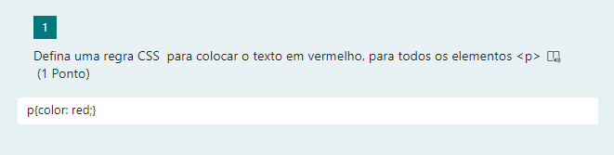

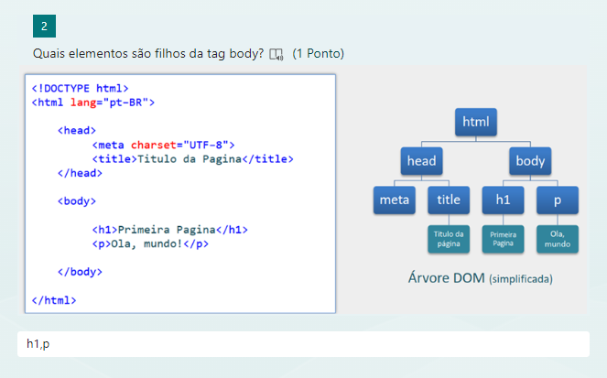

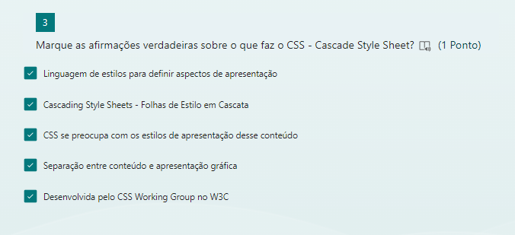

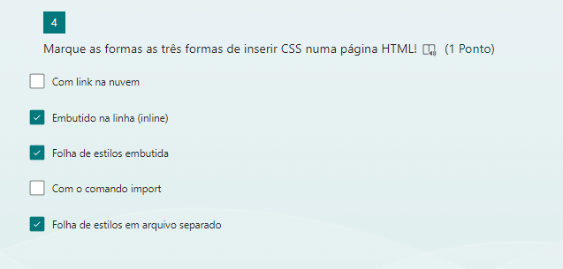

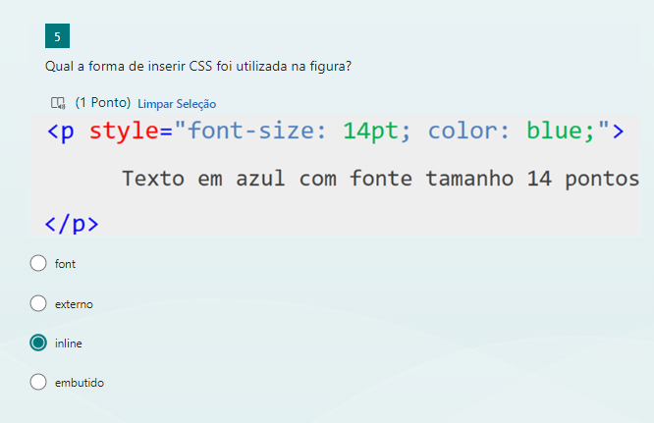

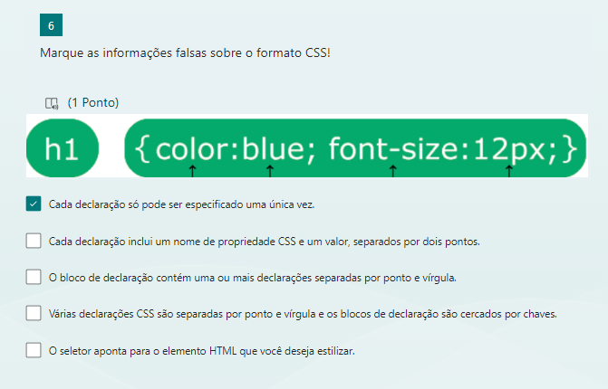

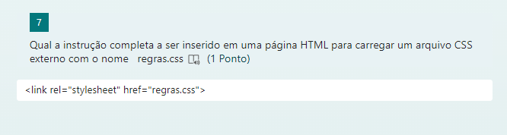

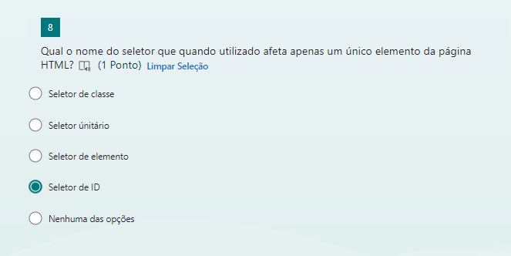

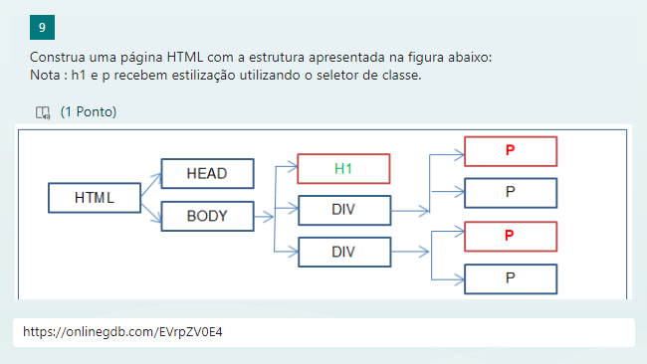

[**https://onlinegdb.com/EVrpZV0E4**](https://onlinegdb.com/EVrpZV0E4)

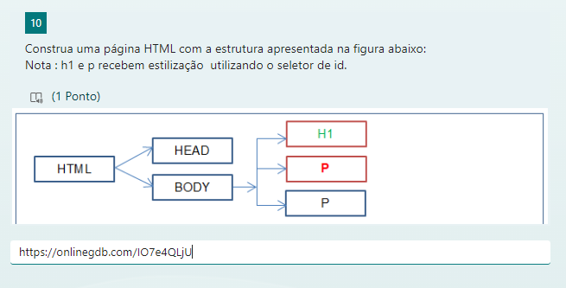

[**https://onlinegdb.com/IO7e4QLjU**](https://onlinegdb.com/IO7e4QLjU)

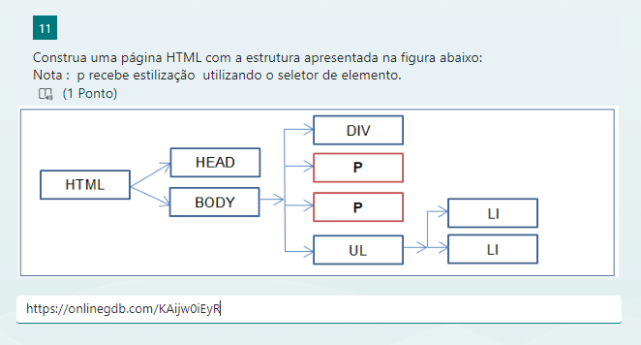

[**https://onlinegdb.com/KAijw0iEyR**](https://onlinegdb.com/KAijw0iEyR)

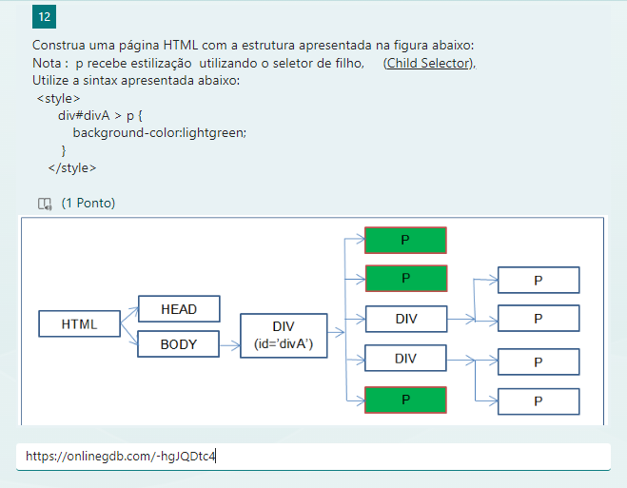

[**https://onlinegdb.com/-hgJQDtc4**](https://onlinegdb.com/-hgJQDtc4)

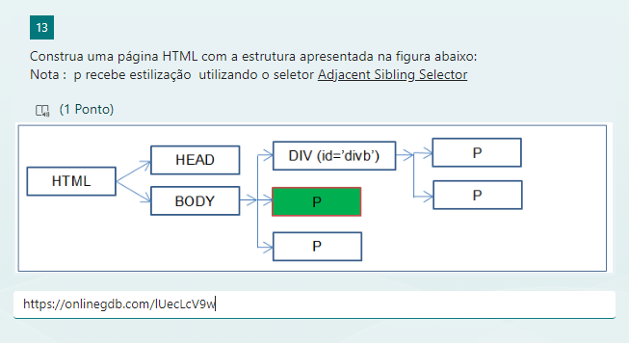

[**https://onlinegdb.com/lUecLcV9w**](https://onlinegdb.com/lUecLcV9w)

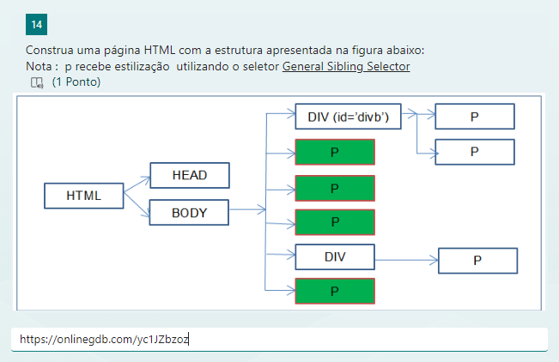

[**https://onlinegdb.com/yc1JZbzoz**](https://onlinegdb.com/yc1JZbzoz)